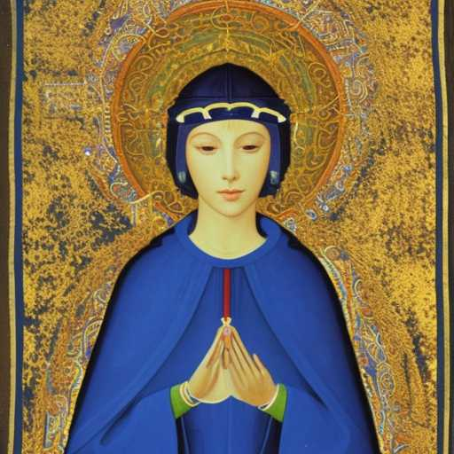
ST. JULIAN’S SAMBHOGAKAYA

St Julian of Norwich writes my soul into the 6th jhana, as a dissolving, effervescent and translucent, interdimensional ecstasy

Saṃbhogakāya is ashes of the dark blue mirror of Nut, the sky goddess and her shimmering golden tapestries

